MATH 3P40 - Mathematics Integrated with Computers and Applications III

Assignment 1

Matt Laidman
5199807

February 6, 2017

Problem 1

The fit of the curve with the maximum population increased to 1000 is a significant improvement over the original data with a maximum population of 100.
As we are working with discrete data the monofera population in unable to increase in a continuous fashion as it would in nature. This is especially noticeable in the plot of the data using 100 cells. When 50 cells are occupied with monofera, there is a 50% population density. The birth of one monofera of course increases this to 51%. There is no possible way to have 50.5% population density, for example.
Increasing the max population (and the number of possible cells) increases the range of population densities which are possible, yielding closer to continuous data and an improved fit to the logistic curve as the maximum population goes to infinity. Increasing the number of cells to just 2500 gives a near perfect fit.
The logistic curve fitting this data has corresponding t_{i} = 144.043 and λ = 0.0367256.
Plots of the monofera population density and the accompanying fitted logistic curve have been included on the following two pages.
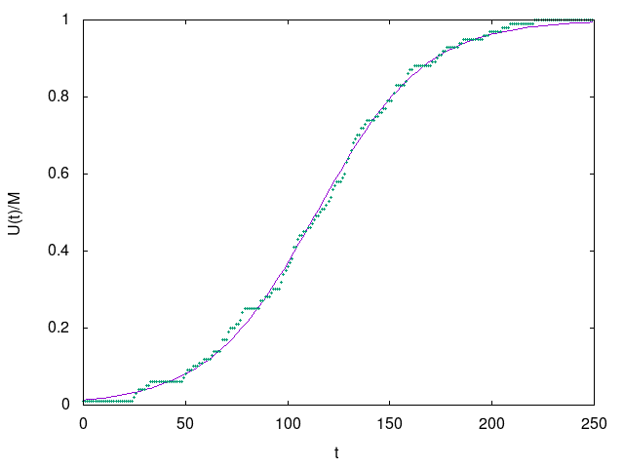Monofera Population Density U(t), M = 100
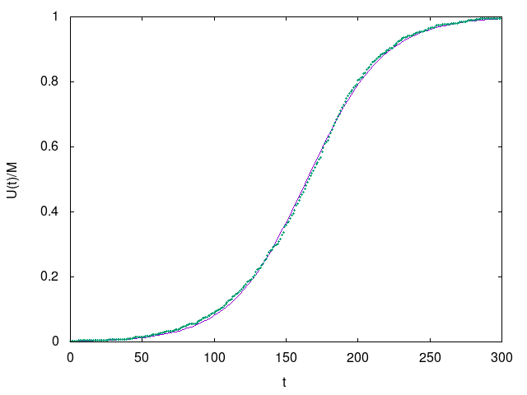
Monofera Population Density U(t), M=1000
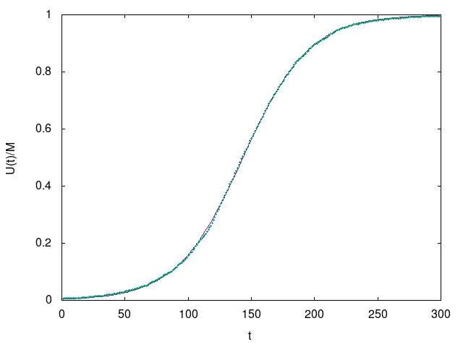
Monofera Population Density U(t), M=2500

Problem 2

Decreasing the probability of a monofera birth at time t from 0.15 to 0.0673 yields an inflection point at approximately twice later. This is visible in the plots below and on the next page.
The original data yeilds t_{i} = 114.113 and λ = 0.0379449. The new data yields t_{i} = 229.829 and λ = 0.0179549.
Monofera Population Density U(t), λ = 0.15
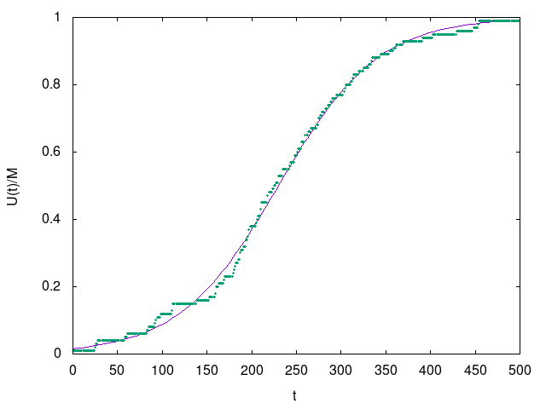
Monofera Population Density U(t), λ = 0.0673

Problem 3

Modifying the program to print universal time, both sets of parameters give the same universal curve. This is verified by the plots of the data below and on the next page.

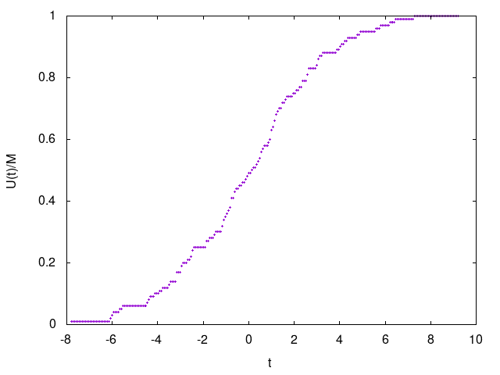
Monofera Population Density U(τ), λ = 0.15
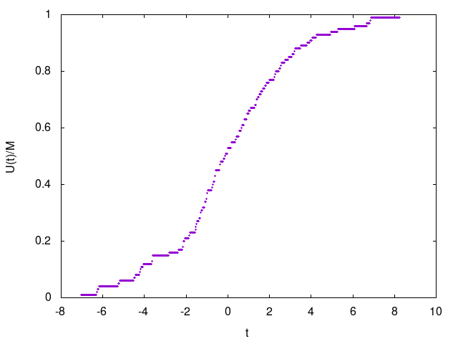
Monofera Population Density U(τ), λ = 0.0673
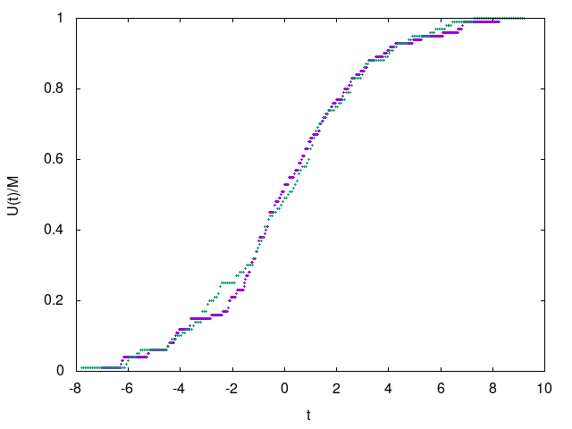
Monofera Population Density U(τ), both λ = 0.15 and λ = 0.0673

